Swansea metropolitan university
Search Algorithms for A.I Entities
Introduction to A.I
Sion Williams p059651
2/19/2008

Contents
Introduction 3
Pathfinding 3
Algorithms 3
Dijkstra’s and Best-First-Search algorithm 4
A* Searching Algorithm 7
Breadth-First-Search Algorithm 9
Depth-First-Search Algorithm 11
Data Structures 12
Linked list 12
Stacks 13
Queues 13
Programming methods 13
Recursion 13
Appendix A - Recursively Solved Maze 14
Appendix B – Simple Linked list Console project 15
Bibliography 17
Project Code Brief (Task 2) 18
Project Revisions information 21
Simple LL maze 21
Recursion Solved Maze 21
Multiple object maze 21
Dungeon final 21

Introduction
This report outlines the different searching algorithms and data structures used in the modern day games industry. I will compare and contrast each algorithm and give a detailed explanation of their operation.

Pathfinding
Movement in game can generally be categorised into two types. The first is a fixed type, for example where a guard will patrol a perimeter. The second is a free wandering movement. Unfortunately there are problems with both; the fixed path can be fooled if an object is pushed in the way. And, the free agent can appear aimless and get stuck (1). In games, the main aim is to achieve believability over accuracy, to achieve this; the A.I must calculate a suitable route through the game level to get from where it is now to its goal. We’d like the route to be sensible and as short as possible. “It doesn’t look smart if the character walks from the kitchen to the living room via the attic” (1). This is known as pathfinding, sometimes called path planning.

Algorithms
The pathfinding algorithms from computer science textbooks work on graphs in the mathematical sense―a set of vertices with edges connecting them. A tiled game map can be considered a graph with each tile being a vertex (were going to consider each tile a node rather than a vertex) and edges drawn between tiles that are adjacent to each other (2):
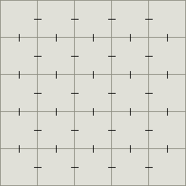
Figure 1 Graph example

Dijkstra’s and Best-First-Search algorithm
Where pathfinding in games has one start point and one goal point, Dijkstra’s shortest path algorithm is designed to find the shortest routes to everywhere from an initial point (1). Dijkstra’s algorithm works by visiting nodes in the grid starting with the entities starting point. It then repeatedly examines the closest not-yet-examined node, adding its node to the set of nodes to be examined (2).
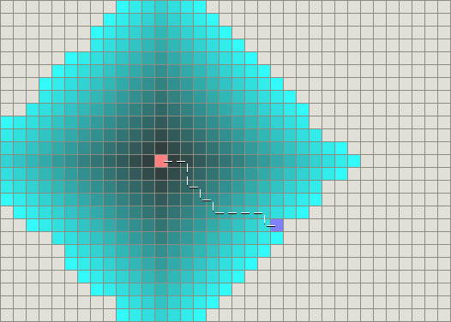
Figure 2 Dijkastra's search (2)
In Figure 2 the pink square is the starting point and the purple is the goal. The lighter blue squares then represent the scanned area.
The Best-First-Search is similar to Dijkstra’s only it uses a heuristic; a heuristic is a form of estimate. In this case the estimate is how far from the goal any node is. The Best-First-Search algorithm explores the graph by expanding the most promising node chosen according by the heuristic evaluation function (3). Best first search is not guaranteed to find the shortest path. However it runs much quicker than Dijkstra’s algorithm because it uses the heuristic function to guide its way towards the goal very quickly.
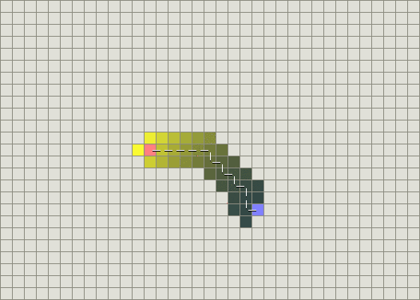
Figure 3 Best First Search (2)
In Figure 3 the yellow represents the nodes with high heuristic values (high cost to get to the goal), the darker the node the lower the cost. Figure 3 shows that the best first search can find paths very quickly; it’s also visible that BFS does a lot less scanning than Dijkstra’s.
However, both cases so far show very simple scenarios, if we’re to consider a maze where the entity is given the problem of overcoming walls, the results change as to which is the best search. Dijkstra’s search when applied to a concaved wall scenario shown in Figure 4 shows far more scanning was undertaken than the BFS equivalent (Figure 5) but a far better path was found.
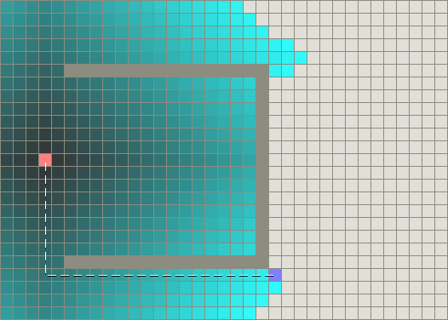
Figure 4 Dijkstra's obstacles (2)
Best first search on the other hand does less work but its path is clearly not as good:
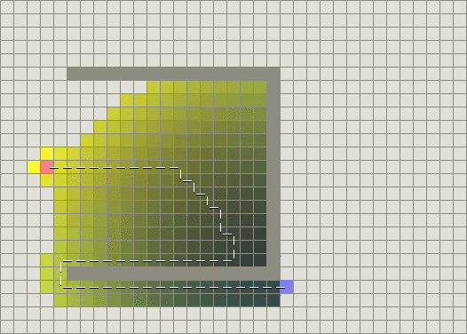
Figure 5 BFS obstacles (2)
The trouble is that best first search is greedy and tries to move towards the goal even if the path isn’t the best (4). Since it only considers the cost of the path so far, it keeps going even if the path it’s on has become really long.

A* Searching Algorithm
The A* algorithm is considered a hybrid of both best first search and Dijkstra’s. A* is just like other graph-searching algorithms in that it can potentially search a huge area of the map. It’s like Dijkstra’s in that it can be used to find the shortest path, but also like best first search in that it can use a heuristic to guide itself.
As we are only interested in the shortest path between two nodes, it seems like a waste to compute all the paths from one node to all the other nodes as Dijkstra’s algorithm does. A* adopts the heuristic method from best first search in order to bias the search toward the destination and thus finish faster (5).
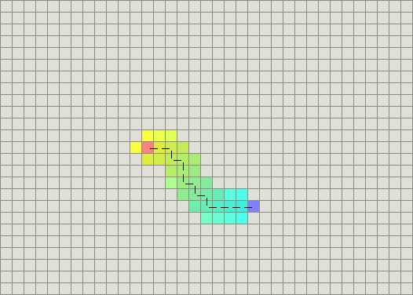
Figure 6 A* search (2)
Figure 6 shows the same search undertaken by the Dijkstra’s and best first search algorithms but shows it reaches the goal as quickly as the best first search.
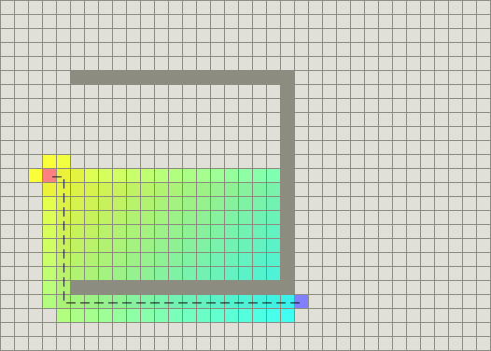
Figure 7 A* obstacles (2)
Figure 7 shows the A* search used in the concave wall example. We can clearly see that a lot less scanning than the Dijkstra attempt has occurred but a far better path than BFS has been found for the same problem. The key to its success is due to its hybrid like nature as described earlier.

Breadth-First-Search Algorithm
Breadth first search (BFS) is one of the simplest algorithms for searching a graph. It can be seen as the model for many other important algorithms, such as, Prim’s minimum-spanning-tree algorithm and Dijkastra’s single-source shortest-paths algorithm (6). BFS is an uninformed search method that aims to expand and examine all nodes of the graph systematically in search of a solution. It does this exhaustively, meaning it searches the entire graph without considering the goal until it finds it.
Figure 8 is an example of a tree; a tree is a way of representing the hierarchical nature of a structure in graphical form (7).

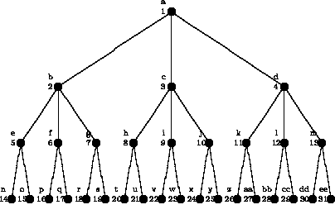
Figure 8 Tree example
Breadth first search operates by examining all successor states at the same depth before going deeper. Assuming “ee” is the goal node, we process as follows:
- To search for the goal node we start with the root node (a)
- We evaluate all the immediate successor states (nodes b, c and d) before looking at the next level that consists of nodes e, f, g, h, i, j, k, l and m.
- We represent this information using a queue type linked list, this queue will consist of [b, c, d]
- Now, we take the sub tree rooted at node b and expand it
- Once done we remove node b from the queue, and place its successors at the end of the list. the list now becomes [c, d, e, f, g]
- As before, now we expand c next, we continue by deriving the successor states from node c, resulting in [d, e, f, g, h, i, j]. Due to the fact were using a queue we always remove from the front of the list to derive the successor (8). Figure 9 is a graphical representation of this.
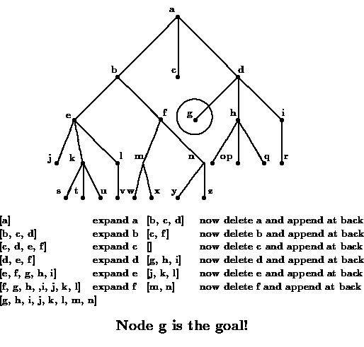
Figure 9 Breadth first search list (8)

Although breadth first can be a very good approach to a searching problem, there are problems with this search. The first, the memory requirements are a bigger problem for breadth first search than the execution time (4). The table below shows the huge memory requirements of the breadth first search; it shows memory requirements reaching as high as 111 terabytes at a depth search of 12.

Depth | Nodes | Time | Memory
0 | 1 | 1 Millisecond | 100 bytes
2 | 11 | .1 Seconds | 11 Kilobytes
4 | 11,111 | 11 seconds | 1 megabyte
6 | 10⁶ | 18 minutes | 111 megabytes
8 | 10⁸ | 31 hours | 11 gigabytes
10 |  | 128 days | 1 terabyte
12 |  | 35 years | 111 terabytes

The second problem is that the time requirements are still a major factor (4). The depth search of 10 taking 128 days to complete simply wouldn’t cut it. In general, exponential complexity search problems cannot be solved for any but the smallest instances (4).

Depth-First-Search Algorithm
DFS was the searching method used for this project. DFS work very similar to BFS but when storing the successor data, a stack is used as opposed to a queue. Also, where BFS looked at node b, c and d before looking deeper into the tree in the previous example, now it looks into all the nodes below b before looking at node c. Here’s the mechanics:
- Start at root node (a)
- Evaluate the successors and place nodes b, c and d in the stack ready for exploration [b, c, d]
- As node b is now head of the list, this is the next node to be examined.
- Take the sub tree at node b and derive its successors (expand the node)
- Replace node b by its successors e, f and g. Due to using the stack data structure, we simply place the successors at the head as follows [e, f, g, c, d].
- Now we repeat from steps 3 until the goal is found or the list is empty in which case no goal exists

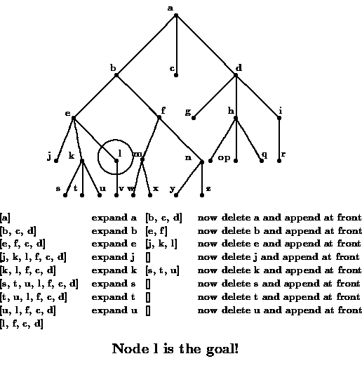
Figure 10 Depth first search list (8)
Depth first search only requires storage for bm nodes where b is the branching factor and m is the maximum depth. In contrast to breadth first search where b is the branching factor and d is the solution at any point on the level. The differences are massive. Using the table above, at a depth d=12 depth first search requires 12 kilobytes instead of 111terabytes, that’s a factor of 10 billion times less space (4).

Data Structures

Linked list
The data structures used throughout this project all stem from linked lists. There are several types of linked lists, and many ways of implementing them. Below are a few examples.

Stacks
There are several ways of implementing stacks but the approach taken for this project was to use a singly linked list where all insertion and deletion taken place at one end, this end we called the head. Other names for stacks are pushdown lists and LIFO or last-in first-out lists (9).
The intuitive model of a stack is a pile of poker chips on a table, books on a floor, or dishes on a shelf, where it is only convenient to remove the top object on the pile or add a new one above the top (9).

Queues
A queue is another kind of list, where items are inserted at one end but unlike stacks, are deleted at the other end. Another name for this type of list is a FIFO or first-in first-out list. The operations for a queue are analogous to those for a stack, the substantial differences being that insertion happens at the end of the list, rather than at the beginning (the head).

Programming methods

Recursion
Throughout this assignment the traversal of trees has been done via adding nodes to linked lists. Another way of doing so would be using recursion (see Appendix A). A recursive implementation of tree traversal has been seen as more natural than a stack based implementation, both because trees are recursively defined structures and because preorder, inorder and postorder are recursively defined processes (10). Unfortunately there is no convenient way of using recursion to solve the breadth first search algorithm as there is no convenient way to implement a recursive procedure for level-order. The very nature of recursion dictates that sub trees be processed as independent units, and level order requires that nodes in different sub trees be mixed together (10).

Appendix A - Recursively Solved Maze
#include <iostream>
using namespace std;

int col= 1;
int row= 2;
const int ROWMAX = 11;
const int COLMAX = 16;

char maze[ROWMAX][COLMAX] =
{
{'B','B','B','B','B','B','B','B','B','B','B','B',' B','B','B','B'},
{'B','S',' ',' ',' ',' ',' ',' ',' ',' ',' ',' ',' ',' ',' ','B'},
{'B','B','B','B','B','B','B','B','B','B',' ','B','B','B',' ','B'},
{'B','F',' ',' ',' ',' ',' ',' ',' ','B',' ','B',' ','B',' ','B'},
{'B','B','B','B','B','B','B','B',' ','B','B','B',' ','B',' ','B'},
{'B',' ',' ',' ',' ',' ',' ','B',' ',' ',' ',' ',' ','B',' ','B'},
{'B','B','B','B','B','B','B','B',' ','B','B','B','B','B',' ','B'},
{'B',' ',' ',' ','B',' ',' ',' ',' ','B',' ',' ',' ',' ',' ','B'},
{'B','B','B',' ',' ',' ',' ',' ','B','B','B','B',' ','B','B','B'},
{'B',' ',' ',' ','B','B','B',' ',' ',' ',' ',' ',' ',' ',' ','B'},
{'B','B','B','B','B','B','B','B','B','B','B','B',' B','B','B','B'}
};

void printMaze();
void runMaze(int, int);

void printMaze()
{
for(int row = 0; row < ROWMAX;row++)
{
for(int col = 0; col < COLMAX;col++)
cout << maze[row][col];
cout << endl;
}
}

void runMaze(int row, int col)
{
if((row > 0 && row<ROWMAX) && (col > 0 && col < COLMAX))
{
if(maze[row][col] == 'F')
{
return;
}else if(maze[row][col] ==' ')
{
maze[row][col] ='*';

runMaze(row, col+1);
runMaze(row, col-1);
runMaze(row-1, col);
runMaze(row+1, col);
}

}
system("cls");
printMaze();
}

int main()
{
cout << "maze done" << endl;
runMaze(1, 2);
return 0;
}

Appendix B – Simple Linked list Console project
#include"Linkedstack.h"
#include<iostream>
#include"stdlib.h"
using namespace std;

bool found= false;
int row = 1;
int col = 2;
const int ROWMAX = 11;
const int COLMAX = 16;

char maze[ROWMAX][COLMAX] =
{
{'B','B','B','B','B','B','B','B','B','B','B','B',' B','B','B','B'},
{'B','S',' ',' ',' ',' ',' ',' ',' ',' ',' ',' ',' ',' ',' ','B'},
{'B','B','B','B','B','B','B','B','B','B',' ','B','B','B',' ','B'},
{'B','F',' ',' ',' ',' ',' ',' ',' ','B',' ','B',' ','B',' ','B'},
{'B','B','B','B','B','B','B','B',' ','B','B','B',' ','B',' ','B'},
{'B',' ',' ',' ',' ',' ',' ','B',' ',' ',' ',' ',' ','B',' ','B'},
{'B','B','B','B','B','B','B','B',' ','B','B','B','B','B',' ','B'},
{'B',' ',' ',' ','B','B','B',' ',' ','B',' ',' ',' ',' ',' ','B'},
{'B','B','B',' ',' ',' ',' ',' ','B','B','B','B',' ','B','B','B'},
{'B',' ',' ',' ','B','B','B',' ',' ',' ',' ',' ',' ',' ',' ','B'},
{'B','B','B','B','B','B','B','B','B','B','B','B',' B','B','B','B'}
};

void printMaze(); //funtion prototype

void main(void)
{
printMaze();

Linkedstack MazeList; //creates a new empty list

MazeList.push(1,1); //push starting position

int currentx, currenty;
currentx = MazeList.getNodeX();
currenty = MazeList.getNodeY();

while((!found)&&(MazeList.endOfList() != true))
{
MazeList.pop();

if(maze[currentx][currenty] == 'F')
{
found = true;
}
else if(maze[currentx][currenty] == ' '||maze[currentx][currenty] == 'S')
{
maze[currentx][currenty] = '*';
}

if(maze[currentx][currenty+1]== ' '||maze[currentx][currenty+1] == 'F') //North
{
MazeList.push(currentx,currenty);
MazeList.push(currentx,currenty+1);
}
else if (maze[currentx][currenty-1]== ' '||maze[currentx][currenty-1] == 'F') //South
{
MazeList.push(currentx, currenty);
MazeList.push(currentx, currenty-1);
}
else if (maze[currentx-1][currenty]== ' '||maze[currentx-1][currenty] == 'F') //West
{
MazeList.push(currentx, currenty);
MazeList.push(currentx-1, currenty);
}
else if (maze[currentx+1][currenty]== ' '||maze[currentx+1][currenty] == 'F') //East
{
MazeList.push(currentx, currenty);
MazeList.push(currentx+1, currenty);
}

currentx = MazeList.getNodeX();
currenty = MazeList.getNodeY();

system("cls");
printMaze();
}

}
void printMaze()
{
for(int row = 0; row < ROWMAX;row++)
{
for(int col = 0; col < COLMAX;col++)
cout << maze[row][col];
cout << endl;
}

}

Bibliography
1. Millington, Ian. Artificial Intelligence For Games. s.l. : Morgan Kaufmann Publishers. 0-12-497782-0.
2. Patel, Amit J. Introduction to pathfinding. Amit’s Game Programming Information. [Online] http://theory.stanford.edu/~amitp/GameProgramming/AStarComparison.html.
3. Pearl, Judea. Heuristics: Intelligent Search Strategies for Computer Problem Solving. s.l. : Addison-Wesley. 9780201055948.
4. Norvig, Stuart Russell & Peter. Artificial Intelligence: A Modern Apporach. s.l. : Prentice Hall, 2003. 0-13-790395-2.
5. Jonsson, F.Markus. An optimal pathfinder for vehicles in real-world digital terrain maps. Stockholm : The Royal Institute of Science.
6. T Cormen, C Leiserson, R Rivest, C Stein. Intorduction to Algoritms. s.l. : McGraw-Hill Book Company, 2002. 0-07-013151-1.
7. Tree Structure. Wikipedia. [Online] http://en.wikipedia.org/wiki/Tree_structure#Examples_of_tree_structures.
8. Different search methods. Introduction to AI programming. [Online] 9 2 1996. http://www.comp.lancs.ac.uk/computing/research/aai-aied/people/paulb/old243prolog/section3_6.html#SECTION0006000000000000000.
9. Alfred V. Aho, John Hopcroft, Jeffrey Ullman. Data Structures and Algorithms. s.l. : Addison Wesley, 1985. 0-201-00023-7.
10. Unknown. Recursive Tree Traversal (handout).
11. Linked List. Wikipedia. [Online] 24 02 2008. http://en.wikipedia.org/wiki/Linked_list.

Project Code Brief (Task 2)
1*Given maze, mouse and cheese position
2*Stack current mouse position
3*Set found to false
4*While not found and stack not empty
5*Pop current position
6*If position is cheese position
7*Set found to true
8*Else if position has no trail
9*Lay trail
10*Move north, east, south, west
11*Endif
12*Endwhile
13*Return found

Move north:
Push current mouse position(x,y)
Push position (x,y+1)

The pseudo code above is the algorithm for exploring a tiled game map using a depth first search. This was implemented into the project almost exactly. To show the similarity I have numbered each step of the pseudo and shown the corresponding steps in the “Simple LL maze” project code, shown page 18.
The dungeon in this example was created using a 2 dimensional array, in the array a ‘B’ represented a blocked position, ‘S’ represented the start, ‘F’ was given for the finish and a blank space ‘ ‘ shown a free pathway. When each connecting node is visited (step 10) if not blocked, their x and y positions which were taken from the 2d array indexes were stored in node data structures. These were in turn placed on the “MazeList” stack.

Linkedstack MazeList;
//step 2
MazeList.push(1,1);

int currentx, currenty;
currentx = MazeList.getNodeX();
currenty = MazeList.getNodeY();

// step 4
while((!found)&&(MazeList.endOfList() != true))
{
// step 5
MazeList.pop();
// step 6
if(maze[currentx][currenty] == 'F')
{
// step 7
found = true;
}
// step 8
else if(maze[currentx][currenty] == ' '||maze[currentx][currenty] == 'S')
{
// step 9
maze[currentx][currenty] = '*';
}

//step 10
if(maze[currentx][currenty+1]== ' '||maze[currentx][currenty+1] == 'F')
{
MazeList.push(currentx,currenty);
MazeList.push(currentx,currenty+1);
}

//For step 10; the code above was replicated and made applicable to that particular move ie. South = “Mazelist.push(currentx, currenty-1);”

currentx = MazeList.getNodeX();
currenty = MazeList.getNodeY();

system("cls");
printMaze();
// step 11
}

// step 12
}

Project Revisions information

Simple LL maze
his project is fully operational. A 16x11 maze array is given to the program where ‘F’ is the finishing node. Once this node is found the program will terminate. The console application shows the trail from start to finish.

Recursion Solved Maze
This program is almost identical to the simple LL maze only this project is solved using recursion as opposed to linked lists.

Multiple object maze
Finished but with problems. An initial list is created that finds all objects and reports their x, then y components to the console. This list creates another list to allow OpenGL to simulate the movement of the sphere; it’s a queue list as opposed to the stack used for the searching.
*There is no file loading included in this project.
*Crashes when reaches end of list.

Dungeon final
Again, this project is finished but with problems. This project is an object oriented approach to the problem. File loading is included and will dynamically load any map with any number of objects, so long as the number of objects is given followed by width and height of map.
Features:
- Created using classes
- Includes file loading
- Object locations stored in list + printed
- Dynamic map loading
- OpenGL – although problem with textures
- Choice of 3 mazes
* When the animation finishes and the list is empty for the sphere pathway, the program crashes. Due to running out of time I was unable to solve the problem.

